Week 2 Exercises: UI, Components and Modularization. Local development environment (VS Code + Android Device/Emulator)
Learning Objectives
After completing this exercise, you should be able to:
- Set up a local React Native development environment with Expo and VS Code
- Create and run a basic Expo project
- Run a React Native application in a web browser or Android emulator
- Build and style a React Native user interface
- Use StyleSheet and Flexbox for layout
- Create reusable React components
- Pass data to components using props
- Divide an application into multiple components and files
- Use a UI component library such as React Native Paper

Part 1: UI and Component Libraries
Answer the following questions briefly:
- What are the purposes of View, Text, Image and Pressable in React Native?
- Why does React Native use its own components instead of HTML elements?
- What are StyleSheet and Flexbox used for?
- What is React Native Paper?
- What is Material Design?
- What advantages and disadvantages can a UI component library provide compared with styling components yourself?
Recommended answer length: approximately 0.5–1 page.
Part 1: UI and Component Libraries
- View is a container used to group and lay out other elements, similar to a div in web. Text is used to display text like in React Native all text must be inside a Text component. Image displays pictures or icons, from either a local file or a URL. Pressable is a wrapper that detects touches, so we can make any element respond when the user taps the buttons, cards or list items.
- React Native apps are not web pages. They run as real native mobile apps, so there is no browser or HTML DOM. Instead of HTML tags like div or p. React Native provides components like View and Text that are translated into each platform’s real native UI elements like a TextView on Android. This is what lets the same code produce a genuine native look and good performance on both Android and iOS.
- StyleSheet is the API used to define styles a JavaScript objects, keeping styling organized and separate from the layout, similar to CSS. Flexbox is the layout system React Native uses to arrange components. It controls direction like flexDirection, alignItems and how space is shared flex, making layouts adapt to different screen sizes.
- React Native Paper is a popular UI component library for React Native. It provides ready-made, good-looking components such as buttons, cards, text inputs and app bars which follows Google’s Material Design guidelines, so we don’t have to build our own and style them from scratch.
- Material Design is a design system created by Google that defines guidelines for how user interfaces should look and behave, for example, covering colors, typography, spacing, shadows and components. Its goal is a consistent, clean and familiar experience across apps. React Native Paper follows these guidelines.
- For the advantages, it saves development time, gives a professional and consistent look out of the box, handles accessibility and platform differences for us, and it keeps the code cleaner. For the disadvantages, we have less control over the exact appearance, customizing components to a unique design can be harder, it adds an extra dependency and some file size, and we have to learn how that particular library works.

Part 2: Local Development Environment
Set up a local React Native development environment using Expo and Visual Studio Code.
You will need:
- Node.js
- Visual Studio Code
- Expo
- a web browser and/or Android emulator
Create an Expo Project
Open the VS Code terminal and create a new blank JavaScript Expo project:
npx create-expo-app@latest my-app --template blank
Move into the project directory:
cd my-app
Start the Expo development server:
npx expo start
Run the Application in a Web Browser
When the Expo development server is running, press:
w
to open the application in a web browser.
Verify that the default Expo application starts successfully.
Android Studio and Android Emulator
To test the application on Android, install Android Studio.
In Android Studio:
- Open Device Manager.
- Create an Android Virtual Device (AVD) if you do not already have one.
- Start the Android emulator.
- Wait until Android has fully started.
Then start Expo in the VS Code terminal:
npx expo start
When the Android emulator is running, press:
a
in the Expo terminal to open the application on Android.
The basic development workflow is:
VS Code
|
| npx expo start
v
Expo
|
+-- w --> Web browser
|
+-- a --> Android emulator
Modify App.js so that the application displays your own text. Verify that the application updates when you save the file.
Your goal is to get the application running successfully either:
- in an Android emulator, or
- at minimum, in a web browser.
Take a screenshot of the running application.
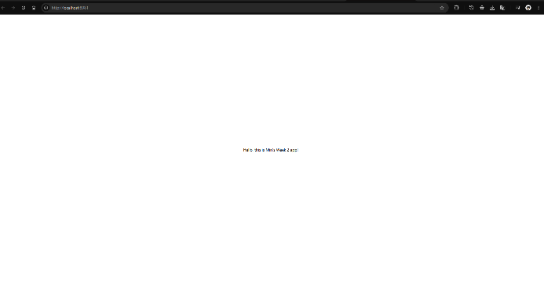
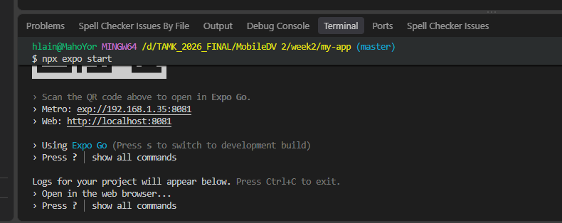
Part 3: Build a Simple Application
Create a small React Native application. Choose your own application topic.
Your application must contain:
- a clear application title
- multiple pieces of information or data
- at least one interactive element
- a visually structured layout
Use React Native core components and StyleSheet to build the initial user interface.
Your styling must demonstrate:
- Flexbox
- spacing (margin / padding)
- typography
- colors
- alignment
The application does not need an API or external data. You may use static data.
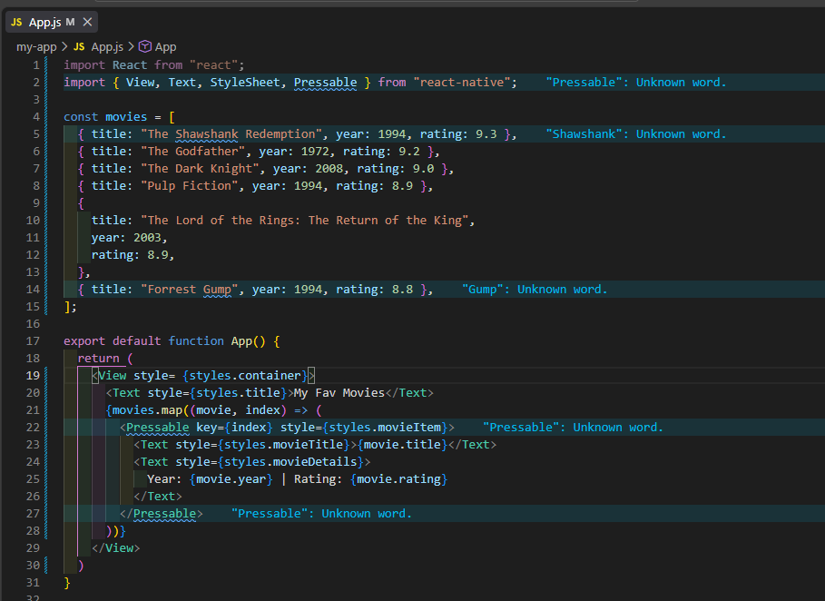
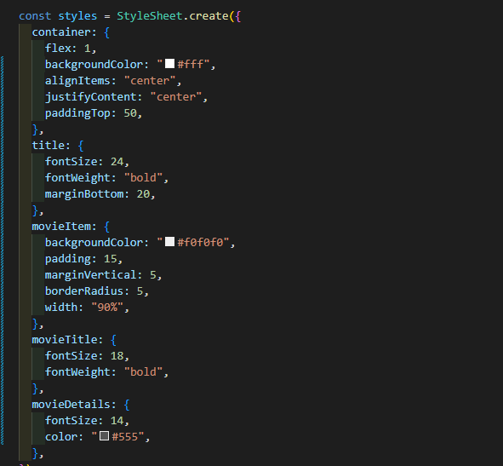
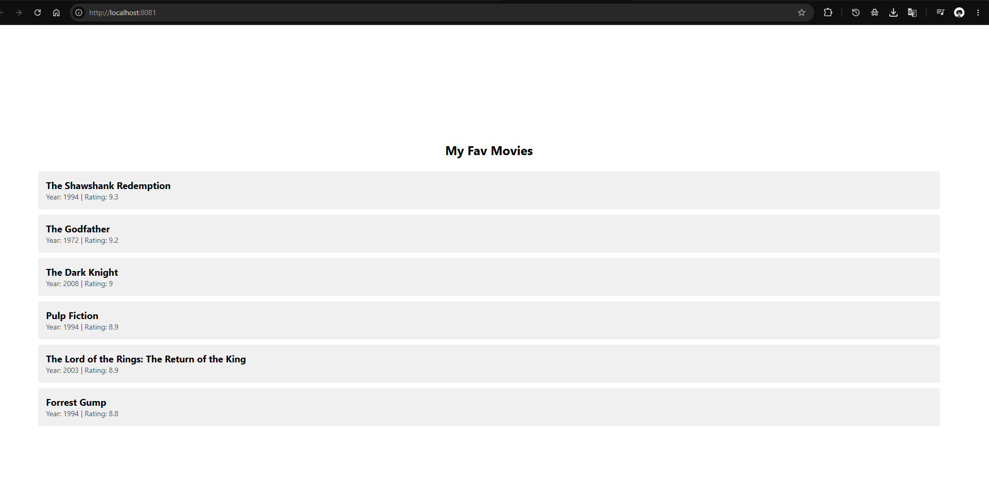

Part 4: Components and Props
Divide your user interface into reusable components.
Create at least two components of your own and place them in separate files.
Your project should have a structure similar to:
project/
|
|-- App.js
|
+-- components/
|-- MainCard.js
+-- InfoItem.js
Pass data from App to your components using props.
At least one of your components should be reusable with different data. Avoid creating multiple components that contain essentially identical UI code.
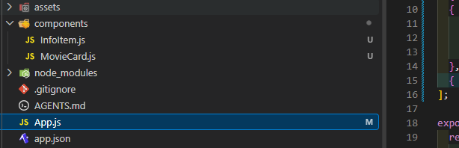
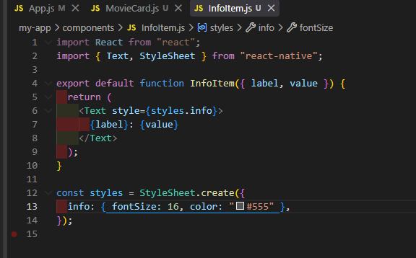
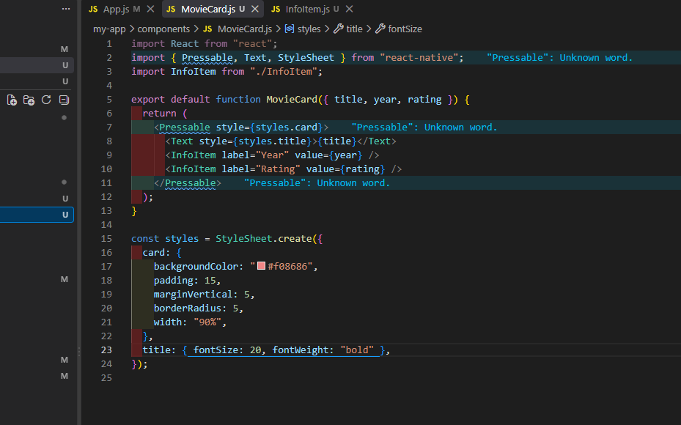
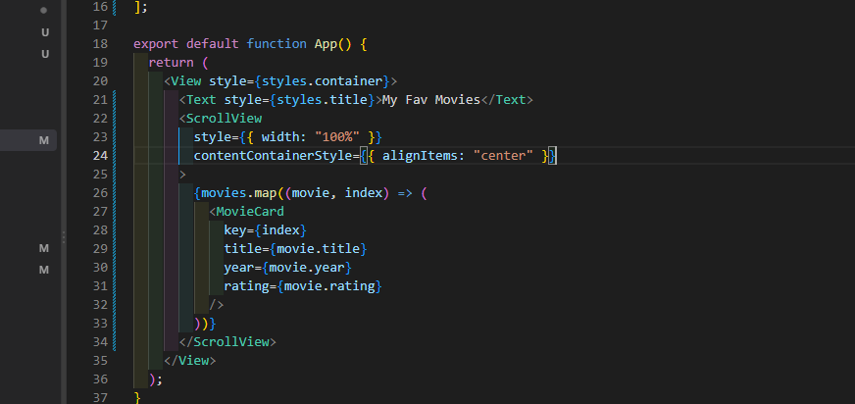

Part 5: State and Interaction
Add at least one state variable using useState.
The state must affect something visible in the user interface.
Add an interaction that changes the state. You can use a button, pressable element, switch, input field or another suitable component.
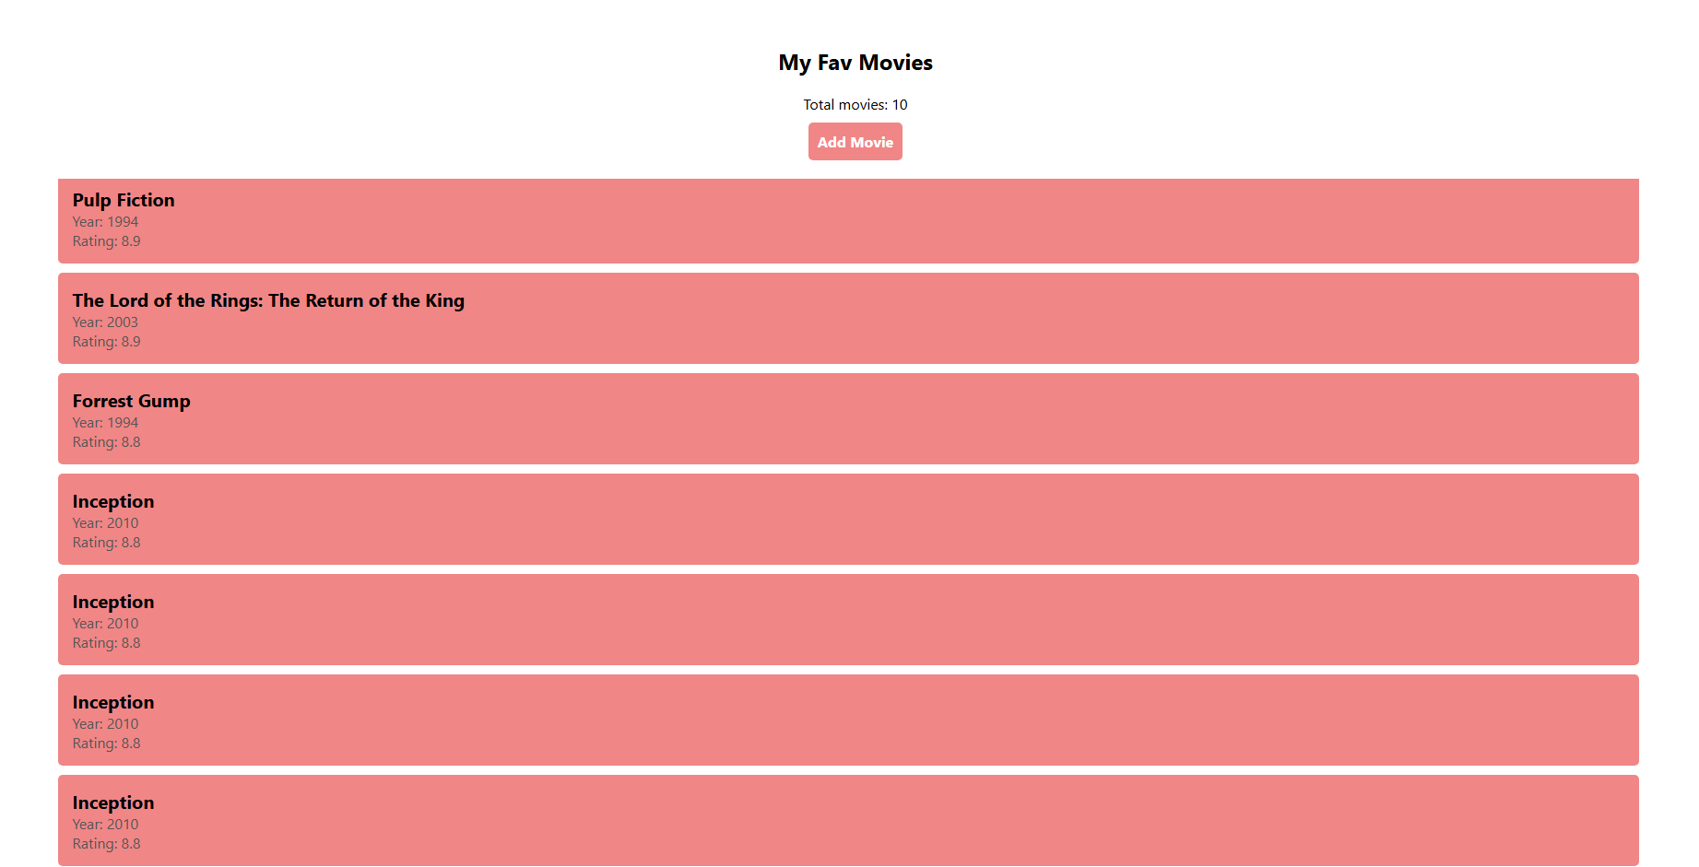
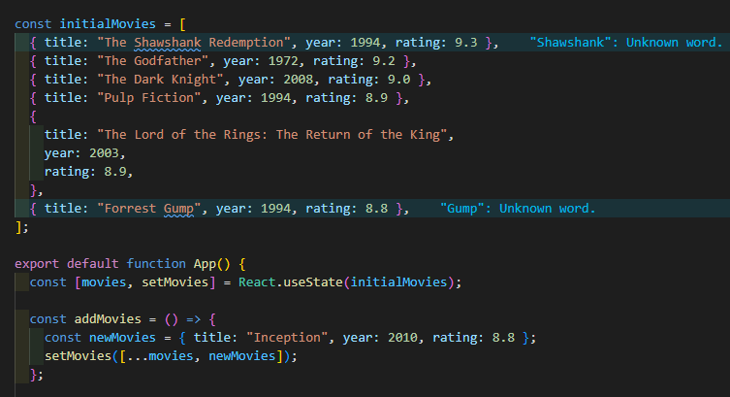
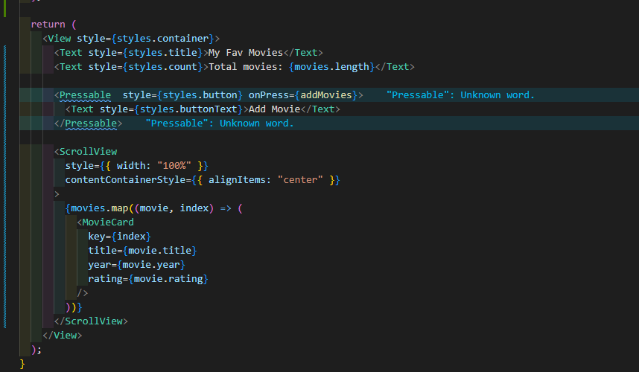

Part 6: React Native Paper
Install React Native Paper in your project:
npm install react-native-paper
Use at least two React Native Paper components in your user interface.
Consider how using a component library changes the appearance and implementation of the application compared with using only React Native core components.
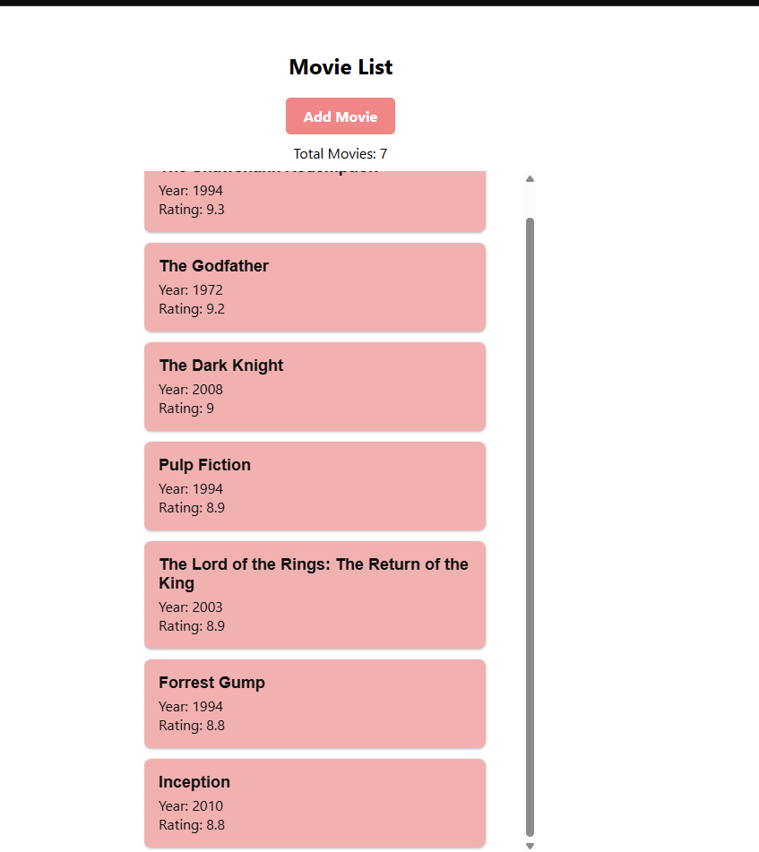
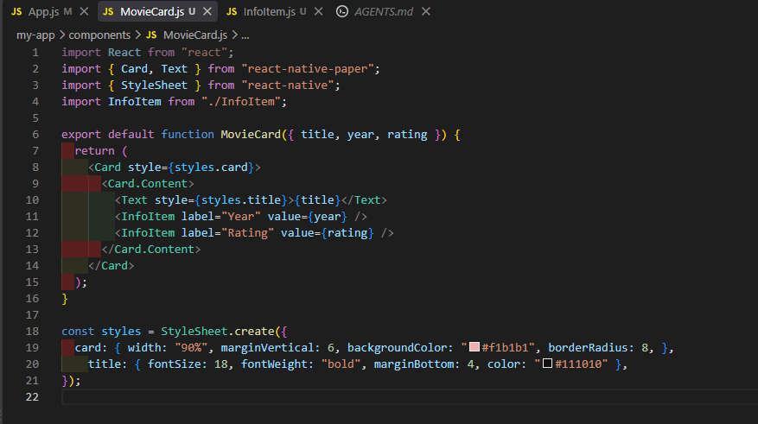
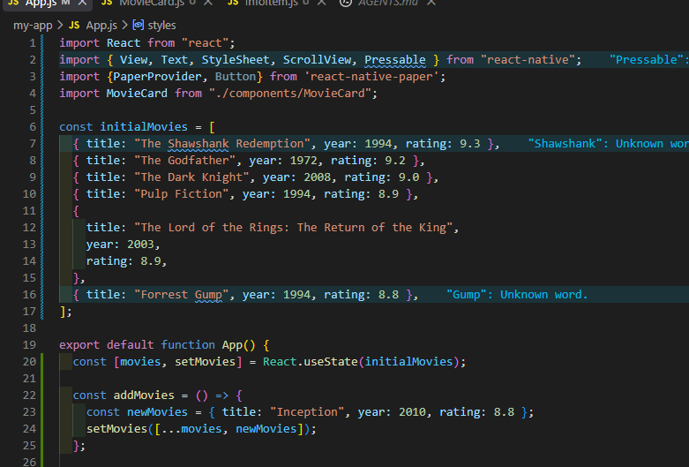
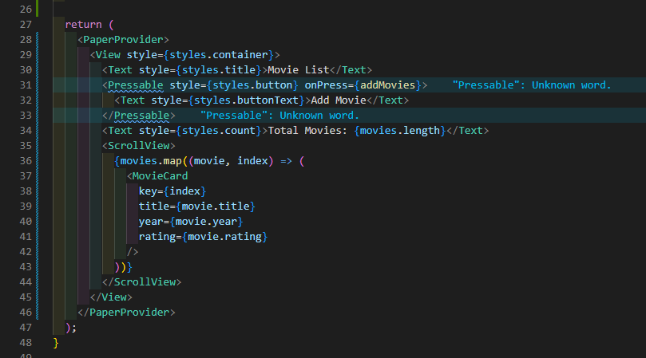

Part 7: Short Reflection
Answer the following questions briefly:
- Why is it useful to divide an application into multiple components?
- What is the difference between props and state?
- What benefit did React Native Paper provide?
- When might you prefer your own component instead of a component from a UI library?
- If you used AI-assisted development tools, what did you use them for and what did you need to understand or verify yourself?

- It keeps the code organized and easier to read, because each component handles one small job. It also avoids repetition for instance, I built one MovieCard component and reused it for every movie instead of writing the same layout. This makes the app easier to update and fix, since a change in one component applies everywhere it is used.
- Props are data passed into a component from its parent and the component cannot change them. I used props to send each movie’s title, year and rating into MovieCard. State is data a component owns and can change itself while the app runs, and when it changes the screen re-renders. I used useState for my movie list so that pressing the button added a movie and the list updated.
- It gave me ready-made, good-looking components that follow material deisgn. So I didn’t have to style them myself. The Paper Button and Card came with proper colors, rounded corners and shadows automatically, which meant less styling code and a more consistent, professional appearance with less effort.
- When I need a specific or custom design that the library doesn’t offer, or when I want full control over the exact look and behavior. Building my own component can also avoid adding an extra dependency for something simple, and it is lighter when the UI is very basic and whole library would be unnecessary.
- I used Claude to learn the React Native concepts with examples and to get the guidance on structuring my components, and to help fix errors for example a missing import and a function name that didn’t match or missed.

Submission
Submit:
- complete source code
- screenshot of the running application
- answers to Parts 1 and 7
Minimum Requirements
Your application must:
- run locally using Expo
- run either in an Android emulator or a web browser
- use React Native core components
- use StyleSheet and Flexbox
- contain at least two components created by you
- divide components into separate files
- use props
- use useState
- include user interaction
- use at least two React Native Paper components

